

Display Screen Equipment (DSE)
Assessment Package
for Individuals Working from Home

This package of information is aimed to help you assess display screen equipment in your home environment. This includes equipment such as Desktop PC’s, laptops and handheld devices such as smartphones and tablets

It will provide guidance should you be experiencing any ill health effects from computer use, and inform you of resources available to address any identified problems.

You should find in this package:

- Part A – DSE Self Assessment:
  - Section 1 – Work area and posture
  - Section 2 – Type of Equipment
- Part B – Homeworking guidance flowchart
- Part C - Health Risks Associated with DSE Use and their Resolution
- Part D – Resources Available to Address Identified DSE Problems
- Part E – Hand Held Device Posture Tips

Summary of actions required (to be completed by line manager)
Member of staff’s name
Action Required |  |  | By Whom? | Date Action Completed
Manager’s Name
Date

PART A - DSE Self Assessment

Use this form to assess your working area.

About you
Your name
Your job title
Dept. & Directorate

About your work | Hours
How many hours do you work each week?
In a typical workday, how many hours do you spend using a computer?

Section 1 – Work area, posture and health
About your work area | Yes | No | Things to consider
Do you have access to a desk/office type space? |  |  | See homeworking flowchart in Part B for further guidance
Do you have clear access to your working area? |  |  | Remove items that restrict access. For example reorganise layout of work area, remove clutter, tidy cables.
Do you have enough space to move your chair around?
Is your work area free from obstructions and tripping hazards?
Is there room to move your legs under the desk? |  |  | Items stored underneath the desk should be removed
Is there enough surface space for your work and equipment? |  |  | Create more space by moving clutter, printers, unused equipment etc. elsewhere

About your work and any software you use | Yes | No | Things to consider
Can you carry out computer tasks in standing instead of sitting to vary your posture? |  |  | Where possible use other surfaces in the home as a standing workstation, e.g., kitchen worktop, ironing board etc.
Do you have non-screen activities in your daily work routine? |  |  | It is important to break up the time spent on the computer. This can be done by formal breaks or by changes in activity that allow the user to move away from the computer e.g. where possible stand up and make a phone call instead of sending an email.
Can you organise your time to have breaks from computer tasks?
Is it easy for you to understand how to use the computer software? |  |  | See below
Have you had enough training to use the software? |  |  | If not, discuss with your manager the courses that may be appropriate for you

About lighting, temperature and noise | Yes | No | Things to consider
Do you have enough light for all your work tasks? |  |  | If insufficient lighting, consider re-positioning lights/lamps
Is your work area free from uncomfortable glare and reflections? |  |  | Ideally workstations should be side on to windows so rearrange position if possible.
Are there blinds or curtains at the windows that can be closed (partially or fully)? |  |  | Sometimes useful to reduce glare and reflection from the sun
Is the temperature of your work area comfortable for you most of the time? |  |  | Adjust heating / clothing to your comfort
Is the work area quiet enough for concentration and phone conversations? |  |  | Make phone calls in a quieter room. Consider location to avoid distractions such as televisions or people.

About your seated posture | Yes | No | Things to consider
Do you sit with your head up and look straight ahead most of the time? |  |  | Check the height of your monitor (top should be in line with eyebrows). Consider a document holder when using paper documents. If you do a lot of reading, try placing documents on lever arch file sloping towards edge of desk or writing board.
When you work at the computer, are your shoulders relaxed? |  |  | Ensure chair height is adjusted so that lower arm is horizontal. Check that the keyboard and mouse are within easy reach. The keyboard should be placed directly in front of you with the mouse adjacent
If you use a keyboard or mouse, are your wrists straight (not turned out or in)
When using the keyboard, are your wrists flat (not up or down)? |  |  | Consider altering the angle of the keyboard by using the feet at the back
Does the seat support the curve in your lower back? |  |  | Try altering the back height to ensure lower back is well supported
Are your feet flat on the floor or on a stable footrest? |  |  | If feet don’t sit flat on the floor when chair at comfortable height for using the computer then a footrest is recommended
Do you have approximately 2-3 finger gap between the front of your chair and the back of your calf? |  |  | If not then check if your chair has got seat (depth) slide (usually a lever under your chair)  Consider swapping your chair for one with a different size seat.
If you have armrests on your chair do they allow you to get close to your workstation |  |  | Consider altering height of armrests if possible or removing them.

About your health | Yes | No | Things to consider
Can you focus on your screen without any visual difficulties? |  |  | Ensure screen is roughly arm’s length away
Are your eyes free from dryness, soreness or itching at work? |  |  | Look up from the screen regularly and focus on something in the distance. Get up and walk to another room / look out of a window
Have you had an eye test in the last 2 years? |  |  | Ask your manager to email ergonomics@uhb.nhs.uk for details of eye tests
Are you free from recurring pains or discomfort? |  |  | Complete Part C of the form to provide further guidance

About training and information | Yes | No | Things to consider
Have you been shown how to adopt good posture at work? |  |  | If no, you should complete the Trust DSE training found on moodle.  Consult the Trust intranet for dates for onsite eye and eyesight testing.
Have you had training and information in how to adjust your workstation?
Have you been given information on how to avoid visual fatigue?
Have you been given information about the provision of eyesight tests?
Have you been informed of the importance of regular activity changes?
Do you know where to report any problems with your workstation? |  |  | Upon completion of this form, discuss all problems with your manager

Section 2 - Equipment
About your work chair | Yes | No | Things to consider
Is your chair comfortable? |  |  | See homeworking flowchart for further guidance if you do not have a traditional office chair.  Adjust the chair if it is not comfortable e.g. altering the back height so that your lower back is well supported.  If the chair is broken then it should be replaced
Is your chair stable?
Does your chair swivel?
Can you adjust the seat height?
Can you adjust the backrest height?
Can you adjust the backrest angle?
Is the chair in good condition?
About your display screen | Yes | No | Things to consider
Is the top of the monitor at about eyebrow height? |  |  | Change height of monitor if adjustable, place a box file or similar under screen if non-adjustable.
Can you tilt and swivel the monitor easily?
Can you read the information on the screen easily? |  |  | Make sure the screen is clean and the background and text colours work together
Can you adjust the brightness and the contrast of the screen? |  |  | Can be done using the buttons at the bottom of the monitor
Is the screen image stable and free from flicker? |  |  | If no, try using different screen colours to reduce flicker, e.g. darker background and lighter text. If problems persist then ask IT to check the equipment
About your keyboard and mouse | Yes | No | Things to consider
Is your keyboard separate from the screen? |  |  | Laptops should be placed on a riser with a separate keyboard.
Can you adjust the angle of the keyboard? |  |  | This can be done by using the feet on the keyboard.
Can you read all the symbols on the keyboard easily? |  |  | Keyboards should be kept clean. If characters still can’t be read then the keyboard may need modifying or replacing.
Does your mouse/trackerball run smoothly? |  |  | See if cleaning is required. Check the work surface is suitable. A mouse mat may be required.
Is the mouse positioned close to you? |  |  | Move the mouse so that it is close to the keyboard to eliminate the need to stretch.
Do you find your mouse comfortable to use? |  |  | Consider using keyboard shortcuts.  Keep your wrists flat and straight. Do not grip mouse, instead use a relaxed hand and take your hand away from the mouse when not in use.

About your work documents | Yes | No | Things to consider
Can you work from your documents with your head upright? |  |  | Consider using a document holder
Do you have a suitable document holder? |  |  | Useful when working from paper documents.
Is a document holder required? |  |  | Consider the type of document you work with when selecting a document holder. If not touch typist consider document holder positioned between keyboard and screen.

If you use a laptop as your main computer then please complete the section below. If not, please proceed to the handheld device section

About your laptop | Yes | No | Things to consider
Do you use a docking station/laptop stand with separate keyboard and mouse? |  |  | A docking station/riser allows the height of the screen to be altered. If the screen is still not high enough, try an alternative docking station/riser or using your laptop as a hard drive with a separate screen, keyboard and mouse.
If you transport your laptop to other locations have you been provided with a suitable bag or trolley? |  |  | A rucksack allows the weight of the laptop to be distributed evenly across both shoulders. Bags with wheels and a height adjustable handle (similar to a suitcase) can also be useful.

If you use handheld devices then please complete the section below. If not, please proceed to the further comments section

Handheld Device | Yes | No | Advice
Does the device fit comfortably in your hand? |  |  | Devices and humans come in a variety of sizes! When choosing a device, try holding it in your hand to ensure you choose one comfortable for your hand size. When using your device, change your grip often and change hands or stop using it if you start to experience discomfort in your hand.
Does the device feel a comfortable weight? |  |  | We often hold devices in our hand when using them; when choosing a device, think about how heavy it is.
Are the characters clear and readable on the display? |  |  | Make sure the screen is clean and the background and text colours work together.
Is the text size comfortable to read? |  |  | Increase the text size if difficult to read.
Is the image stable, i.e. free of flicker? |  |  | If no, try using different screen colours to reduce flicker, e.g. darker background and lighter text.
Are the brightness and/or contrast adjustable? |  |  | Have a look at your settings to see if the brightness and contrast can be altered.
Is the screen free from glare and reflections? |  |  | Try moving away from any sources of glare and reflection e.g. windows or lighting.

How You Use The Handheld Device | Yes | No | Advice
Do you use your device for typing short messages (rather than lengthy text)? |  |  | Typing lengthy messages on a handheld device does not encourage good posture. Try to avoid lengthy messages by:  - Typing only short messages;  - Try using multiple fingers on both hands rather than one finger or thumbs;  - Consider voice recognition;  - Try phoning;  - Consider an external plug in keyboard;  - If a lengthy message is unavoidable then take regular breaks and change posture frequently.
Do you use your device for short periods (rather than lengthy spells)? |  |  | Try to avoid lengthy periods of use as handheld device usage often results in undesirable postures such as forward flexion of the head and neck and slouching (particularly when sat on a sofa!).  If you do require prolonged access to the internet or messaging systems then consider using a desk top computer or making a telephone call. In addition, take short and frequent postural breaks.
Do you remain stationary when using your device (rather than walking)? |  |  | Try to remain stationary when using the device; walking and texting puts you at risk of walking into objects and people.
Do you raise your device up when using it (rather than keeping it low and close to your body)? |  |  | To reduce loading on your neck and possible discomfort, try raising your device so that it is closer to eye level. You could also use a stand, bracket or prop the device up on a table in front of you.

If you have any comments that you wish to add, please do so in the box below.

Further Comments

This is the end of the self-assessment of your workstation.
If you have answered “no” to any of the questions some changes may be needed to improve your working situation. This is what you need to do:

- Try to make as many improvements as you can. For example, try to adopt a better posture, rearrange your furniture and work equipment, etc. Then go back to the questions and change the “no” to a “yes” where appropriate.

- Where you are not able to make changes, for example where if affects lots of people in your work area or where equipment needs to be replaced, take this questionnaire to your line manager and explain what needs to be altered.

- Complete another assessment form after any changes have been made.

A summary of required actions should be written and signed by your line manager in the box provided on the front page of this assessment package.

PART B – Homeworking guidance flowchart

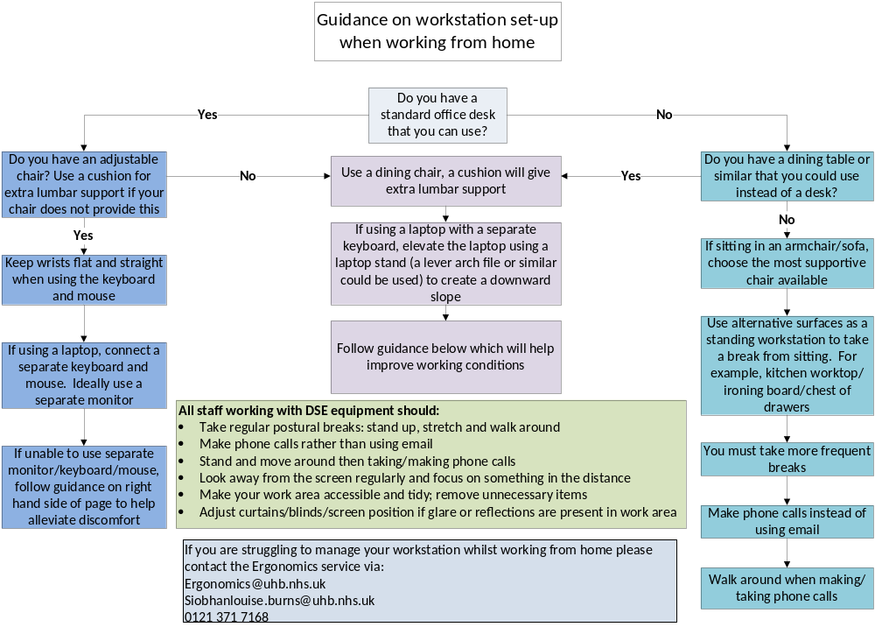

PART C – Health Risks Associated with DSE Use and their Resolution

The following section lists some of the more common health issues that can arise from DSE use. Also identified are the more common causes of these health issues, and what steps can address them. Note this is a guide and not an exhaustive list.

Please tick any of the issues that apply to you, and tick the appropriate suggested resolutions to then put in your action plan.

 | Symptom | Common Cause(s) |  | Suggested Resolutions
 | Sore neck | Posture |  | Keep head upright
 | Sore neck | Posture |  | Sit back into the chair backrest
 | Sore neck | Posture |  | Consider learning to touch type
 | Sore neck | Posture |  | Change position; stand, stretch and walk around
 | Sore neck | Screen position |  | Screen placed directly in front of you
 | Sore neck | Screen position |  | Top of screen even with your eye level
 | Sore neck | Document position |  | Document holder near computer screen
 | Sore neck | Arm position |  | Arms close to the body, elbows bent 90º
 | Sore neck | Frequent twisting |  | Face the direction you need to pay regular attention to, i.e. entry area if you have a reception role
 | Sore back | Posture |  | Keep head upright
 | Sore back | Posture |  | Keep spine in a normal S-shape
 | Sore back | Posture |  | Sit back into the chair backrest
 | Sore back | Foot support |  | Sit back into the chair
 | Sore back | Foot support |  | Place feet firmly on floor or on footrest
 | Sore back | Chair |  | Ensure chair is comfortable and adjusted appropriately
 | Sore back | Chair |  | Chair should provide low back support
 | Sore back | Chair |  | Seat of chair should support thighs
 | Sore back | Chair |  | If chair is unsuitable, replace it
 | Sore back | Breaks |  | Alternate tasks regularly to vary posture
 | Sore back | Breaks |  | Take short, frequent breaks; change position; stand, stretch and walk around
 | Sore wrists | Position |  | Wrists kept straight and flat when typing
 | Sore wrists | Position |  | Preferably wrists are not resting directly on a surface while keyboarding
 | Sore wrists | Equipment |  | If you cannot type without resting your wrists on a surface, purchase gel wrist rests which provide a soft surface
 | Sore wrists | Equipment |  | For touch typists, ergonomic (split) keyboards can be helpful with improving wrist position
 | Eyestrain | Breaks |  | Alternate tasks to vary posture; make phone calls instead of emailing where possible.
 | Eyestrain | Breaks |  | Take short, frequent breaks. Stand up, stretch and walk around
 | Eyestrain | Screen position |  | Screen placed at fingertip distance when you stretch your arms forward
 | Eyestrain | Screen position |  | Font size large enough for viewing
 | Eyestrain | Corrective lenses |  | Get eyes tested for good corrective lenses
 | Eyestrain | Breaks |  | Alternate tasks regularly to vary viewing distance
 | Headaches | Posture |  | Take short, frequent breaks; Stand up, stretch and walk around
 | Headaches | Posture |  | Keep head upright
 | Headaches | Posture |  | Sit upright with S-shape spine
 | Headaches | Lighting |  | Ensure no glare on screen from light
 | Headaches | Stress |  | Organise work for systematic approach
 | Headaches | Stress |  | Discuss with manager
 | Headaches | Breaks |  | Alternate tasks regularly to vary posture
 | Headaches | Breaks |  | Take short, frequent breaks; stand up, stretch and walk around
Part D – Resources Available to Address Identified DSE Problems
Companies that may be able to provide helpful equipment and furnishings to the Trust include:

Company Name | Emergent Crown
Email | sales@emergent-crown.co.uk
Website | www.emergent-crown.co.uk
Products | This Company is the standard Trust supplier for office furnishings including desks and chairs. The standard chairs purchased from Emergent Crown are as follows:  The chairs are typically suitable for the majority of persons although specialist chairs from one of the other suppliers may be necessary for some with unique requirements.
  Name of chair | Suitable for 24 hour use? | Vinyl option? | Extras
  F2+ | Yes | Yes | - Height adjustable arms  - Seat slide  - Pump up lumbar  - Hard floor castors
  Shape Task | No | Yes | - Height adjustable arms  - Seat slide  - Pump up lumbar  - Hard floor castors
Company Name | Back Care Solutions
Email | Paul Worsley pworsley@backcs.co.uk
Website | www.backcs.co.uk.
Products | This Company provides a range of products suitable for office environments including some more specialised items including bookrest style document holders, high spec. chairs, monitor risers and footrests. Bespoke chairs can be purchased from for people with specific requirements.
Company Name | NHS Supplies
Website | http://my.supplychain.nhs.uk/catalogue
Products | NHS Supplies provides a wide range of standard office equipment aids including document holders, footrests, gel wrist rests, and desk organisers.

Part E –Hand Held Device Posture Tips

If you’re a Hand Held Device user, follow the advice below to reduce the risk of you experiencing discomfort whilst working.

